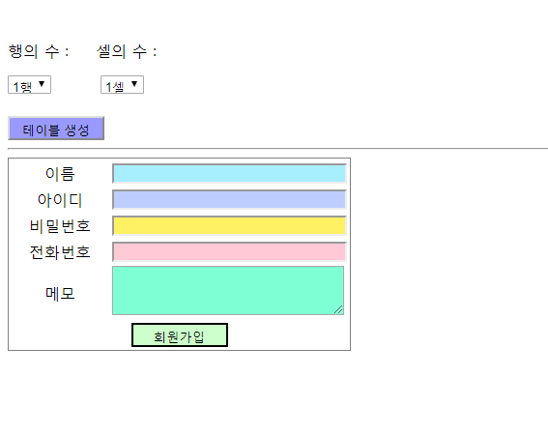

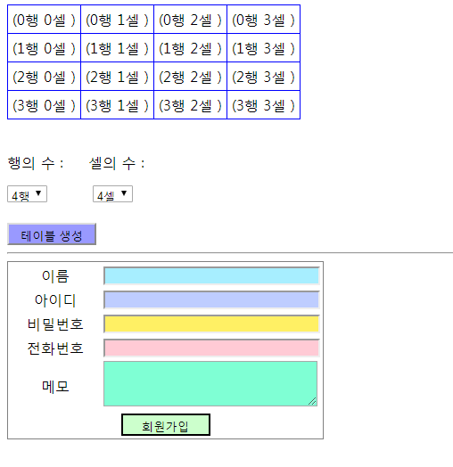

ex0503.aspx [단일 파일 페이지 모델이 안돼서 cs파일로 나눠서 올립니다.]

<%@ Page Language="C#" AutoEventWireup="true" CodeBehind="ex0503.aspx.cs" Inherits="ex00.ex0503" %>

<!DOCTYPE html>

<html xmlns="http://www.w3.org/1999/xhtml">

<head runat="server">

<meta http-equiv="Content-Type" content="text/html; charset=utf-8"/>

<title></title>

</head>

<body>

<form id="form1" runat="server">

<div>

<asp:Table ID="Table1" runat="server" BorderWidth="1" CellPadding="5" CellSpacing="0" GridLines="Both"

BorderColor="Blue">

</asp:Table>

<br />

<p>행의 수 : &nbsp;&nbsp;&nbsp; 셀의 수 :</p>

<asp:DropDownList ID="DropDownList1" runat="server">

<asp:ListItem Value="1">1행</asp:ListItem>

<asp:ListItem Value="2">2행</asp:ListItem>

<asp:ListItem Value="3">3행</asp:ListItem>

<asp:ListItem Value="4">4행</asp:ListItem>

</asp:DropDownList> &nbsp;&nbsp;&nbsp;&nbsp;&nbsp;&nbsp;&nbsp;

<asp:DropDownList ID="DropDownList2" runat="server">

<asp:ListItem Value="1">1셀</asp:ListItem>

<asp:ListItem Value="2">2셀</asp:ListItem>

<asp:ListItem Value="3">3셀</asp:ListItem>

<asp:ListItem Value="4">4셀</asp:ListItem>

</asp:DropDownList><br /><br />

<asp:Button ID="Button1" runat="server" Text="테이블 생성" OnClick="Button1_Click" Height="25" Width="100" BackColor="#9999FF" />

<hr />

<asp:Table ID="Table2" runat="server" BorderWidth="1">

<asp:TableRow>

<asp:TableCell Width="100" HorizontalAlign="Center">이름</asp:TableCell>

<asp:TableCell>

<asp:TextBox ID="TextBox1" runat="server" Text="" Columns="30" BackColor="#A7EEFF"></asp:TextBox></asp:TableCell>

</asp:TableRow>

<asp:TableRow>

<asp:TableCell HorizontalAlign="Center">아이디</asp:TableCell>

<asp:TableCell>

<asp:TextBox ID="TextBox2" runat="server" Text="" Columns="30" BackColor="#BECDFF"></asp:TextBox></asp:TableCell>

</asp:TableRow>

<asp:TableRow>

<asp:TableCell HorizontalAlign="Center">비밀번호</asp:TableCell>

<asp:TableCell>

<asp:TextBox ID="TextBox3" runat="server" Text="" TextMode="Password" Columns="30"

BackColor="#FFF064"></asp:TextBox></asp:TableCell>

</asp:TableRow>

<asp:TableRow>

<asp:TableCell HorizontalAlign="Center">전화번호</asp:TableCell>

<asp:TableCell>

<asp:TextBox ID="TextBox4" runat="server" Text="" Columns="30" BackColor="#FFCAD5"></asp:TextBox></asp:TableCell>

</asp:TableRow>

<asp:TableRow>

<asp:TableCell HorizontalAlign="Center">메모</asp:TableCell>

<asp:TableCell>

<asp:TextBox ID="TextBox5" runat="server" Text="" Rows="3" TextMode="MultiLine" Columns="31"

BackColor="#7FFFD4"></asp:TextBox></asp:TableCell>

</asp:TableRow>

<asp:TableFooterRow>

<asp:TableCell ColumnSpan="2" HorizontalAlign="Center">

<asp:Button ID="Button2" runat="server" Text="회원가입" OnClick="Button2_Click" BorderStyle="Double"

BackColor="#CCFFCC" BorderColor="Black" Height="25" Width="100" />

</asp:TableCell>

</asp:TableFooterRow>

</asp:Table>

</div>

</form>

</body>

</html>

ex0503.aspx.cs

using System;

using System.Collections.Generic;

using System.Linq;

using System.Web;

using System.Web.UI;

using System.Web.UI.WebControls;

namespace ex00

{

public partial class ex0503 : System.Web.UI.Page

{

protected void Page_Load(object sender, EventArgs e)

{

}

protected void Button1_Click(object sender, EventArgs e)

{

int rowCount = int.Parse(DropDownList1.SelectedItem.Value);

int cellCount = int.Parse(DropDownList2.SelectedItem.Value);

for(int i=0; i<rowCount; i++)

{

TableRow row = new TableRow();

for(int k=0; k<cellCount; k++)

{

TableCell cell = new TableCell();

cell.Controls.Add(new LiteralControl("(" + i.ToString() + "행 " + k.ToString() + "셀 )"));

row.Controls.Add(cell);

}

Table1.Rows.Add(row);

}

}

protected void Button2_Click(object sender, EventArgs e)

{

}

}

}